Backup of a database  
or get a copy to move to another machine

BY SCRIPTED EXPORT aka “Generate Script”   
from SQL Server Management Studio

In left-hand database explorer:

Right-click on name of database, in this case “XSpy”   
🡪 Tasks 🡪 Generate Scripts

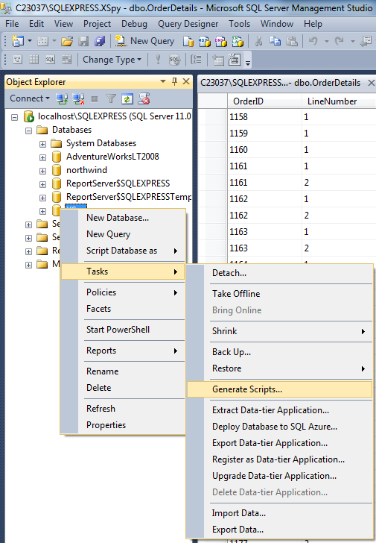

In Brief – straightforward run through this wizard  
EXCEPT – to export data you MUST click an ADVANCED button and change data export option  
Advanced Scripting Options 🡪 “Types of data to script”  
🡪 “Schema and data” (change from default of “Schema only”)

------------------------------

IN Detail  
On intro screen 🡪 Next  
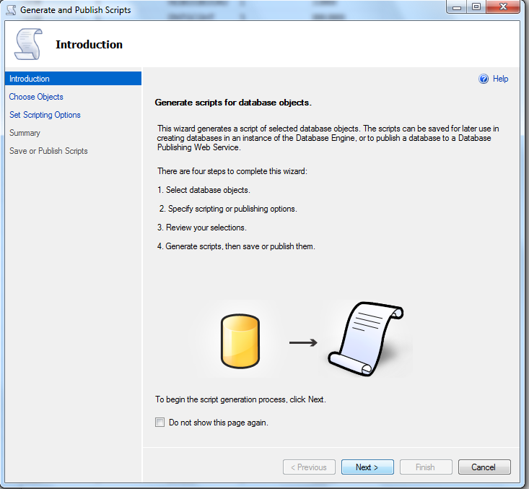

Wizard page 2 – go with default of   
“Script entire database and all database objects”  
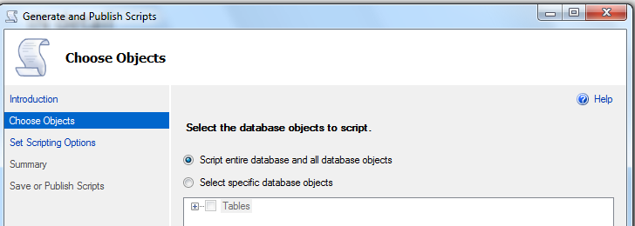

Wizard Page 3 – this is where you MUST click the “Advanced” button  
to export data. Otherwise the default is an empty database.

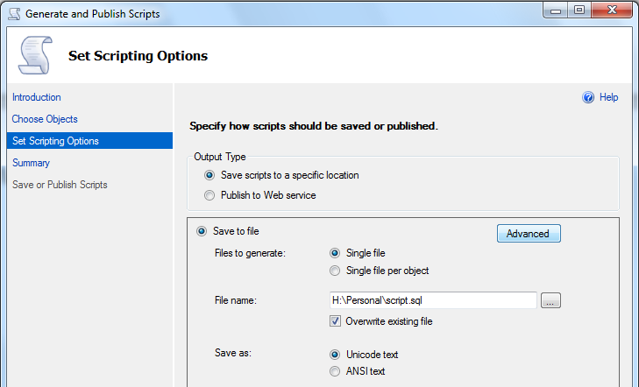

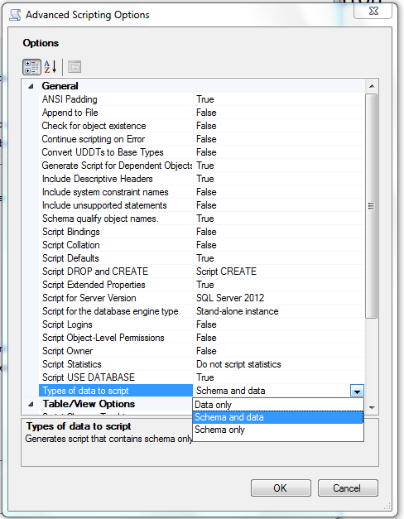

Recommended: For “Script for Server Version” change from SQL Server 2016 or later to “SQL Server 2012”. This simplifies the script, removing advanced options that we do not need at our current level, and reducing the probability that we need to edit the script to get it to run smoothly.

Also recommended – change the “File name” and path.  
The path should be in your development working area.  
The filename should reflect the database name with version information eg the date.

In this case: I:\XTemp_162\Dev\Northwind_20160805.sql

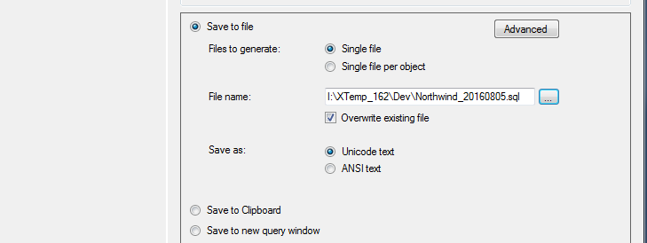

If you forget to do this, you will export a file “script.sql” in your “My Documents” folder.  
After the export, immediately rename this and move it to a better place.

The option “Save to new query window” is good for small databases.  
This will display the SQL code on screen where you can review and make minor edits, then save to a file.

The exported script will begin with a code that we need to delete.  
These include creating the database files – it is better to create an empty database manually before running the script. Code also includes creating database users which we do not have the rights to do on a hosting provider machine. Again, it is better to create an empty database manually which creates with our login as the database user.

We then need to delete the beginning of the script up to the comment before the first “CREATE DATABASE” statement.  
We need to start the script by adding a USE statement at the beginning where we follow USE with the name of the empty database we have created.  
A ready-to-go script then starts like this:

USE [rr_xspy]

GO

/****** Object: Table [dbo].[__MigrationHistory] Script Date: 29/03/2017 12:45:26 p.m. ******/

SET ANSI_NULLS ON

GO

SET QUOTED_IDENTIFIER ON

GO

CREATE TABLE [dbo].[__MigrationHistory](